Дата: 09.12.2022 Клас: 6-Б

Предмет : Англійська мова Вчитель: Глуговська Л.Г.

Тема: Семестрова контрольна робота з письма.

Мета: повторити навички вживання лексичних одиниць з вивченої теми; закріпити граматичне правило вживання слів; удосконалювати навички аудіювання й усного мовлення з опорою на лексико-граматичні структури.

**Хід уроку**

***1. Warming up and reviewing (Розминка)***

***- Hello, children! How are you?***

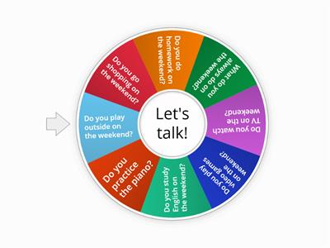

1. **Writing**

***Friday, the ninth of December***

***Control work***

***1. Complete the questions with the question words from the box.***

***Доповніть речення питальними словами.***



1) _______sports are you fond of?  
— I’m fond of football and basketball.  
2) _______ do you usually get up?  
— I usually get up at 7 o’clock.  
3) _______does your sister like eating?  
— She likes eating ice cream  
4) _______is this woman?  
— She is my aunt.  
5) _______are you?  
— I’m fine, thank you.  
6) _______ are you looking at that girl with a little puppy in her arms?  
— I like her pet and want to ask her if the puppy was a present to her birthday.

***2. Put the verbs in brackets into the Present Simple or the Present Continuous Tense.***

***Розкрийте дужки та поставте дієслово у правильному часі.***

1) Ann always­­­­­­__________ (to remember) to buy bread, milk and her favourite chocolates.

2) Sam­­­­­­__________ (not to listen) to music now.

3) My little brother ­­­­­­__________ (to hate) porridge.

4) I ­­­­­­__________ (not to do) my homework now.

5) My friend’s grandparents ­­­­­­__________ (to read) an English text at the moment.

6) His parents ­­­­­­__________ (to love) jazz music.

***3. Circle the correct answer.***

***Оберіть правильну відповідь.***

1) My brother can swim well ... I can’t.

a) so b) and c) but

2) Molly ... aerobics in this gym three times a week.

a) plays b) does c) goes

3) Nick plays volleyball ... basketball.

a) but b) and c) because

4) I like comedies ... they are funny.

a) because b) but c) so

5) At lessons of ... pupils learn about the life of people in the past.

a) History b) Geography c) Maths

6) At ... lessons pupils learn to draw and paint.

a) Music b) IT c) Art

7) At lessons of ... pupils do different mathematical calculations.

a) Maths b) Science c) PE

8) At ... lessons pupils learn to sing and play different musical instruments.

a) History b) Art c) Music

***3. Homework***

Домашнє завдання:

1. Зробити всі завдання діагностичної роботи письмово.

**Надіслати виконані вправи у Вайбер (0964124047) – Людмила Григорівна або прикріпити на Human.**